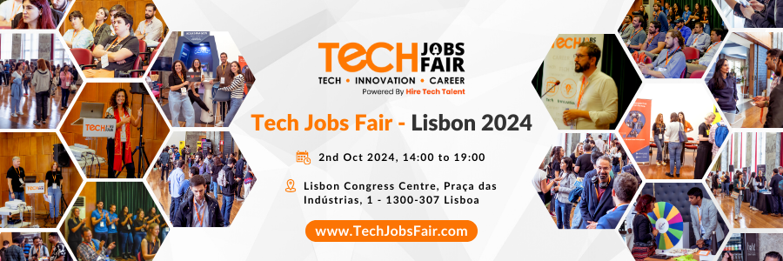

Tech Jobs Fair, a widely recognized platform linking tech enthusiasts with leading companies, is excited to extend an invitation to the upcoming job fair in Lisbon. Scheduled for October 2nd, 2024, the event will take place at Lisbon Congress Centre, Praça das Indústrias, 1 - 1300-307 Lisboa.

Marking its 46th global edition and 6th edition in Lisbon, Portugal, Tech Jobs Fair promises an engaging experience. The event boasts top-tier companies, captivating keynote speakers, and an energetic ambience conducive to meaningful discussions and fruitful networking. Countless individuals are actively contributing to the success of TJF Lisbon in various capacities.

Reflecting on the accomplishments of the previous year, the Lisbon event has witnessed notable achievements. In 2023, it hosted over 20 exhibitors, 15 keynote speakers, and attracted more than 2,000 talents. This year, the anticipation is even higher, with projections exceeding 30 exhibitors, 25 keynote speakers, and an attendance of over 3,000 talents.

This event presents a unique opportunity for both recruits and talents in the tech industry to connect, learn, and grow.

**Benefits of Exhibitors?**

1. **Access to Top Talent:** Tech Jobs Fair attracts a diverse pool of talented individuals eager to contribute to your organization's success.
2. **Brand Exposure:** Showcase company's innovations and values through speaker sessions, raising brand awareness among potential recruits and industry peers.
3. **Networking Opportunities:** Engage in fruitful discussions with industry experts and fellow professionals, fostering valuable connections that can lead to future collaborations and partnerships.

**What Sets Us Apart?**

1. **Personalized Approach:** Event invitations are tailored to address the specific needs and interests of HR professionals and companies, ensuring high satisfaction.
2. **Proven Success:** Tech Jobs Fair has a track record of successful events and satisfied participants, guaranteeing a rewarding experience for all attendees.
3. **Dedicated Support:** The team is committed to providing unparalleled support before, during, and after the event, ensuring a seamless and enriching experience for all.

**Benefits for Talents/Jobseekers?**

1. **Career Advancement:** Discover job openings from top tech companies which offer diverse roles and career growth opportunities.
2. **Networking:** Connect with industry professionals, peers, and potential employers to expand your network and foster valuable relationships.
3. **Knowledge Sharing:** Attend speaker sessions to learn about the latest technologies, industry trends, and career development strategies.

As a job seeker, you can benefit from a FREE ticket to the event, giving you full access to all exhibitors, speaker sessions, and networking opportunities.

**About Tech Jobs Fair:**

Tech Jobs Fair is a renowned platform connecting tech talent with leading companies globally. This year, they are organizing their 16+ events across the globe. TJF provides a platform where companies can meet thousands of talented individuals with desirable skills, offering them the opportunity to hire the best candidates for their needs.

Additionally, Tech Jobs Fair's events provide an advantage for both job seekers and employers, allowing them to engage and connect actively.

The Founder & CEO Ashok Dudhat leads Tech Jobs Fair with a commitment to fostering innovation and career growth; Tech Jobs Fair organizes impactful events worldwide.

Ashok Dudhat's leadership creates a dynamic environment where professionals interact with industry giants, showcasing their expertise and exploring career opportunities. This platform acts as a catalyst for networking, learning, and recruitment in the ever-changing tech landscape.

Join Tech Jobs Fair to navigate the tech job market effectively, guided by the vision of Ashok Dudhat, a driving force in bridging the gap between talent and opportunities.

To join the event, visit: [www.TechJobsFair.com](http://www.techjobsfair.com)

**Organized by:**

Tech Jobs Fair GmbH

Chausseestr 40,

10115, Berlin, Germany.

