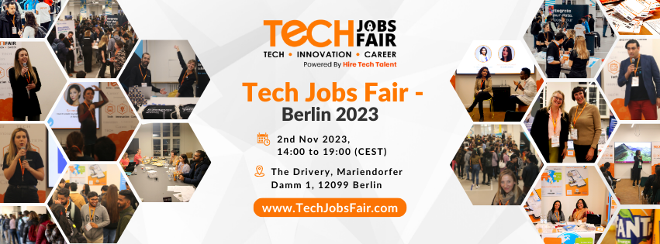

Tech Jobs Fair is excited to announce its forthcoming job fair in Berlin, which will take place on 2nd Nov 2023 with a Tech, Innovation, and Career Concept. This year Tech Jobs Fair - Berlin 2023 will mark its 5th edition in Berlin and its 33rd edition worldwide. and will be held at The Drivery, Mariendorfer Damm 1, 12099 Berlin.

In 2022, There were over 25+ exhibitors, 20+ keynote speakers, and more than 2,000 talents at Tech Jobs Fair - Berlin’22. and this year expects to have more than 30+ exhibitors, 25+ keynote speakers & 3,000+ talents.

This job fair will benefit tech companies in terms of hiring & branding and Jobseekers from the tech industry. Here, job seekers will get the opportunity to meet with recruiters from more than 30+ companies and can find all kinds of Startups, SMEs, and Corporate companies from all around Germany at the fair. The event is open for all the professionals looking for career growth, discovering great ideas, meeting inspiring people, and fresh graduates who want to get wings for their dreams.

For participating companies, It is more than a job fair where your brand will be highlighted. It is a great opportunity for job seekers and employers to find the best from the available resources, and this Tech Festival will surely solve the purpose for many.

In collaboration with TJF's partners, we aim to make Berlin a leading global destination for high-impact companies.

The job fair continues during the day with the company’s booth and professional talks, while social networking ends the Tech Jobs Fair 2023. It is a great opportunity to meet with your peers in a more relaxed and informal environment. Ashok Dudhat, Founder & CEO of Tech Jobs Fair, will be there too, so this is a chance to connect with him.

**More about the Tech Jobs Fair:**

Tech Jobs Fair is a platform to empower brands and bring talent under a single roof. Established by Ashok Dudhat, Tech Jobs Fair, based in Berlin, has grown by leaps and bounds. With a strong emphasis on IT and Digital domains, Tech Jobs Fair, with an acronym of TJF, commenced its first edition in Berlin in 2017. In 2019, it made its mark in three commercial hubs of Europe, viz. Vienna, Zurich, and Lisbon. TJF operates with a core team in Berlin with event-based engagement with local professionals in various cities pertaining to job fairs.

Please check for more details at: [www.TechJobsFair.com](http://www.techjobsfair.com)

**Organized by:**

Tech Jobs Fair GmbH

Potsdamer Str. 36,

14513, Teltow, Germany.

